**Experiment 11:** Change Hardware compatibility of a VM (Either by clone/create new one) which is already created and configured.

Step 1: Creating a New File.

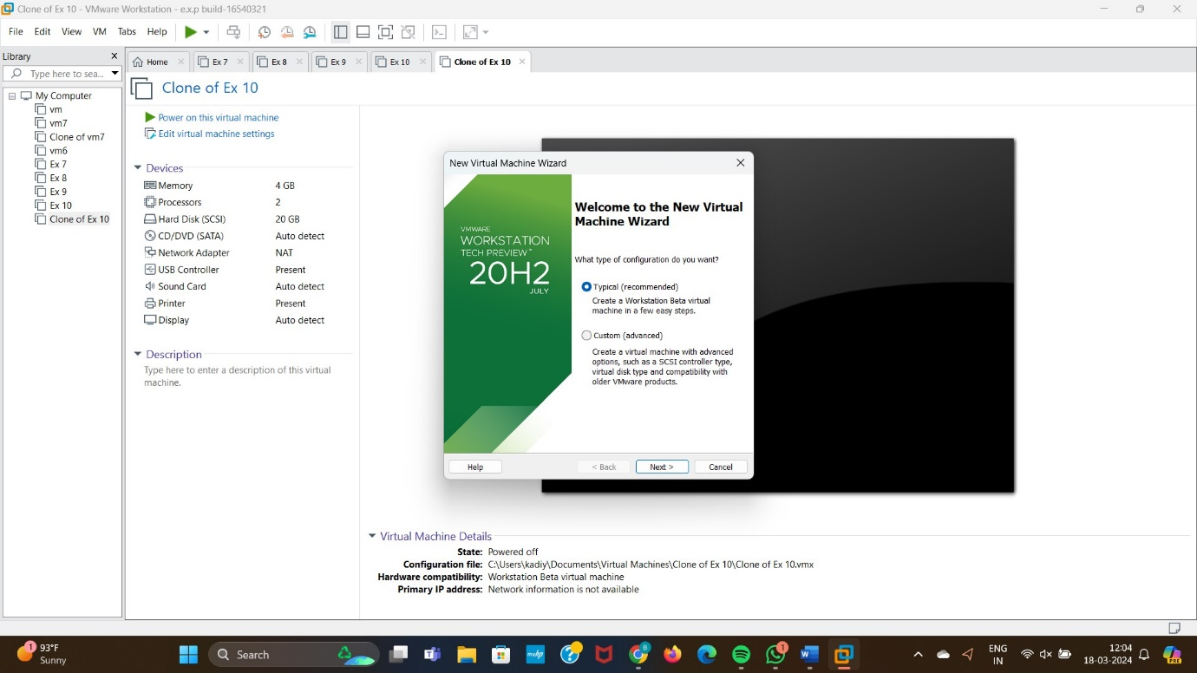

Step 2: Select the I will Install Operating system later option.

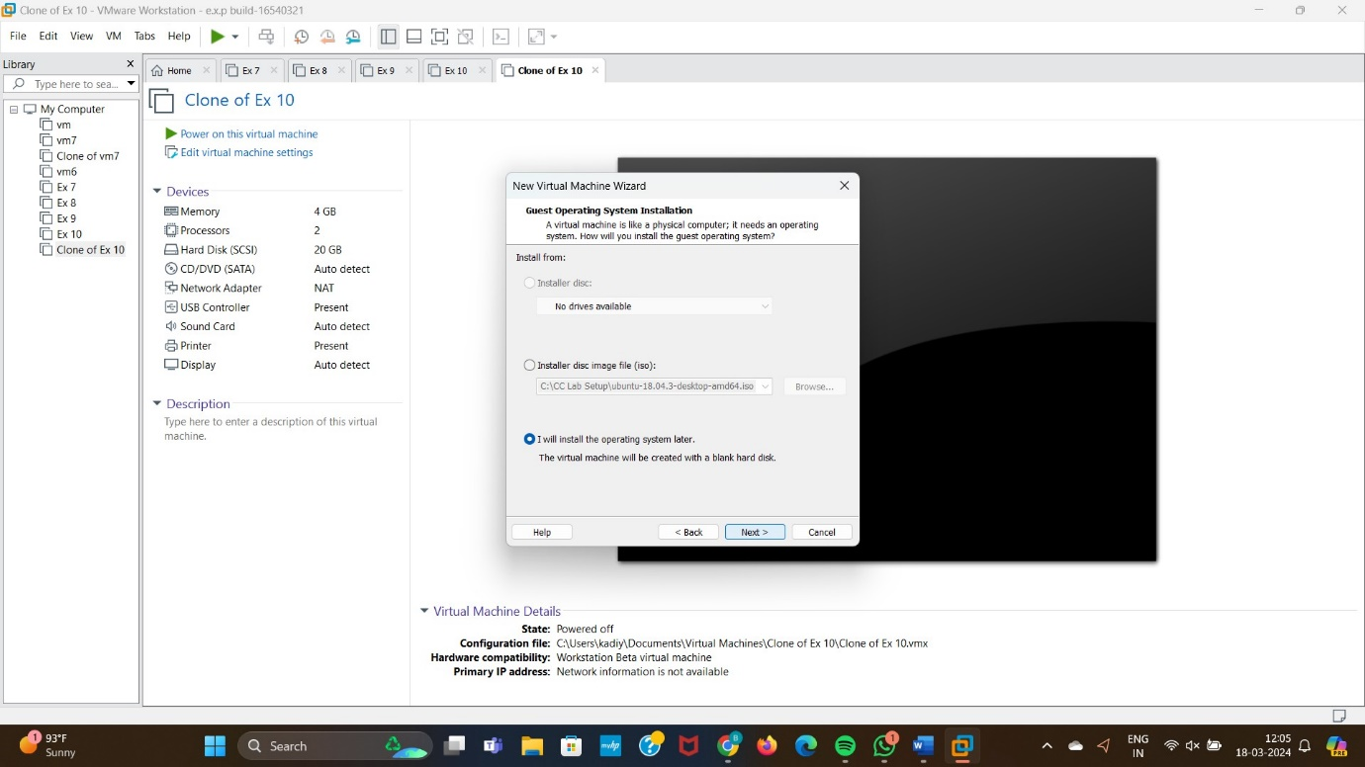

Step 3: Select any Operating System.

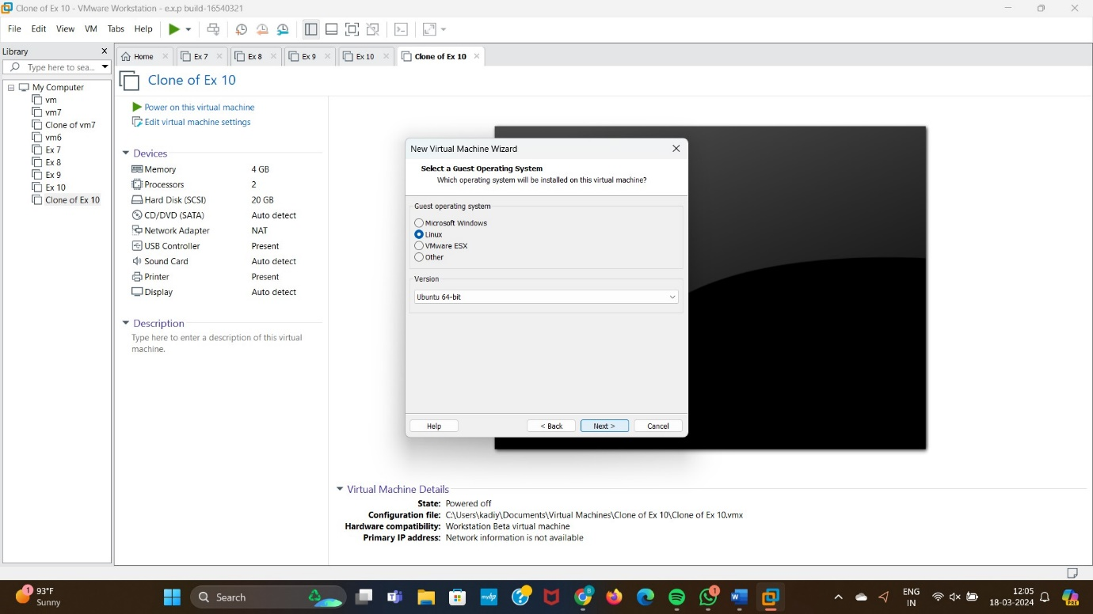

Step 4: Select Single file option.

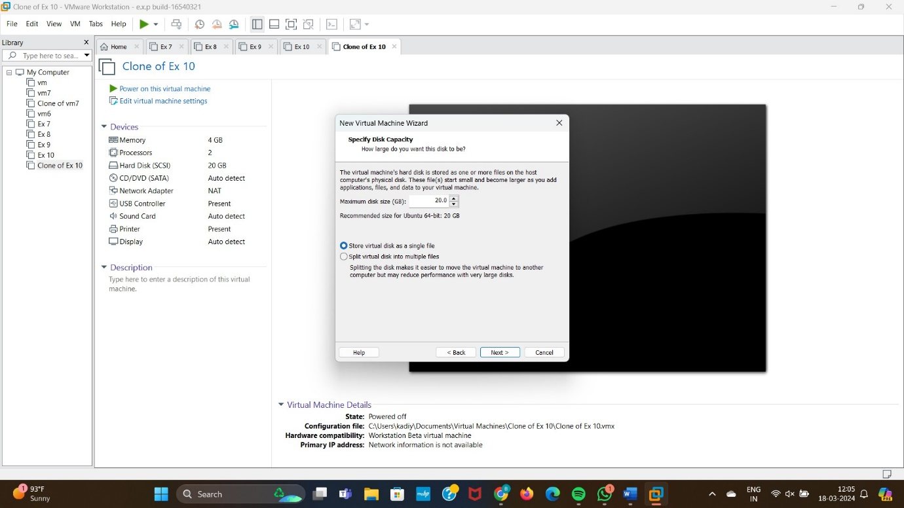

Step 5: Select Finish Option.

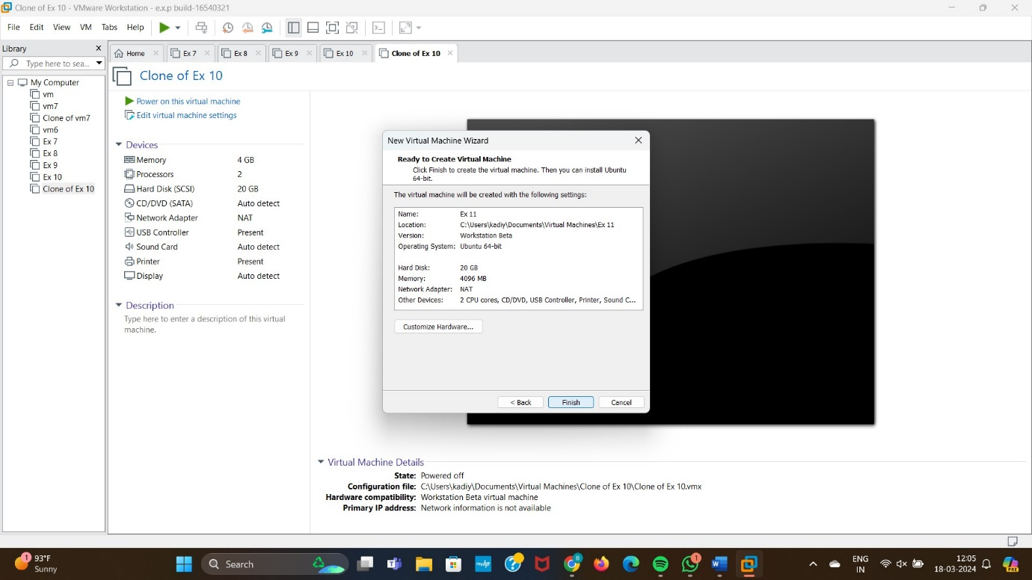

Step 6: Change Hard ware Compatibility.

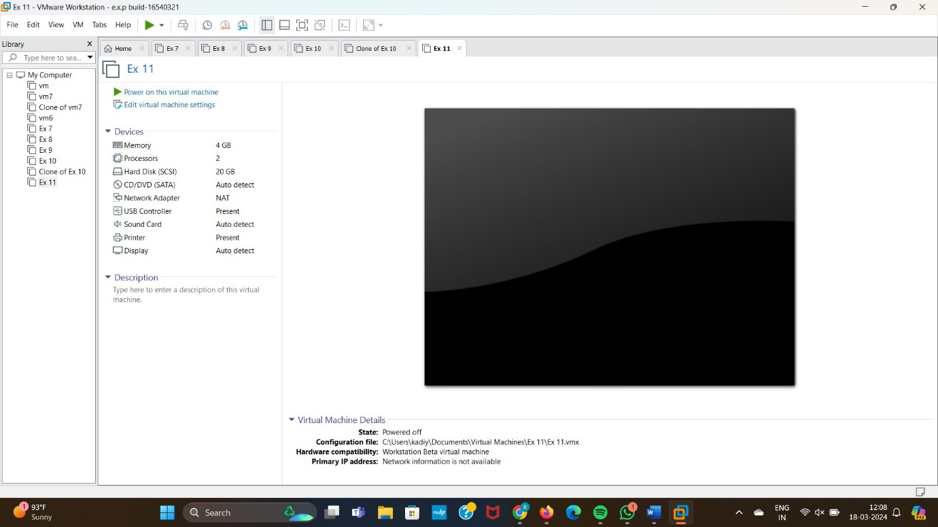

Step 7: Final Output.

